DM952 Lab Report 2

Yumin Huang

201886385

Lab3:

* 1. Plot the dataset you have created and save it as an image for the lab report. For all plots it is advised to add a title, axis labels, and a legend appropriate for the content. Does this data look reasonable to you for the line you have created?

Answer: the figure of dataset is shown in figure 1. And it looks reasonable because every are including noise from y to y_exact.

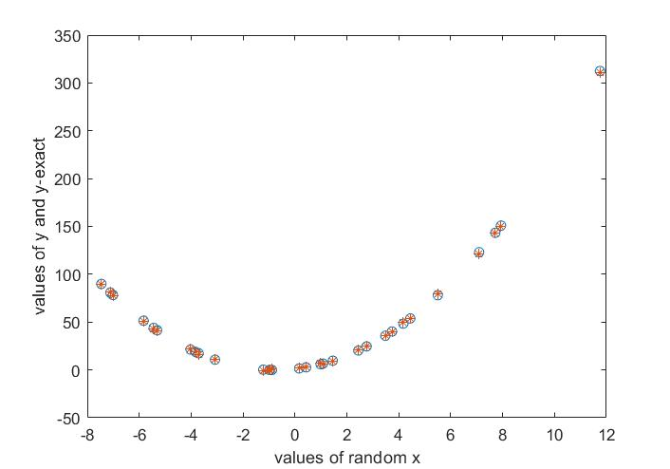

Figure 1. Dataset

* 1. Include the code you have written for polynomial regression in your lab report, and include the weightings that were obtained for each K value, and a brief description of how well they compare with the expected values.

Answer: the code is shown here:

function w =polynomialRegression(k,x,y)

i=length(x);

X1=eye(i,k+1);

for i1=1:1:i

for k1=0:1:k

X(k1+1)=x(i1)^(k1+1);

end

X1(i1,1:k+1)=X;

end

w =(X1'*X1)\(X1'*y);

When k=0, w= 4.9869. When k=1, w= [3.0049;2.0164]. When k=2, w= [2.9322;2.0201;0.0012]. When k=3, w= [2.9550; 2.0894; -0.0021; -8.5921e-04]. When k=3 and y=y_exact, w= [2.9841;2.0191;8.0735e-04].

After try different parameter of dataset, the results form is like [b,a,c]. And no matter the number of c, the result of c always close to 0 even it is too large. And if w= [a,b,c,d] which the polynomial is $y=ax^{3}+bx^{2}+cx+d$, the result will become [c,b,a,d].

* 1. Include the code you have written for evalPolynomial in your lab report, and include a plot saved as an image for predicted points obtained from each K value, a brief description of how well these points fit with the underlying dataset, and whether they represent overfitting/underfitting.

Answer: due to the result in question 1.2, the function will be design as y= d+ $ax+{bx}^{2}+{cx}^{3}+…$ and it is shown here.

function y=evalPolynomial(w,x)

i0=length(w);

i1=length(x);

if(i0<2)

for i11=1:1:i1

y(i11)=w;

end

else

for i11=1:1:i1

y(i11)=w(i0);

for i01=1:1:i0-1

y(i11)=y(i11)+w(i01)*x(i11)^(i01);

end

end

end

The results of function from k=0,1,2,3 and k=2, y=y_exact compare with y are shown in figure 2,3,4,5,6 and these figures show that when k=0,1,results will under fitting and when k=2,3 or k=2,y=y_exact are fitting well. Also, when k=3, the value of c is near 0, so the result will not over fitting.

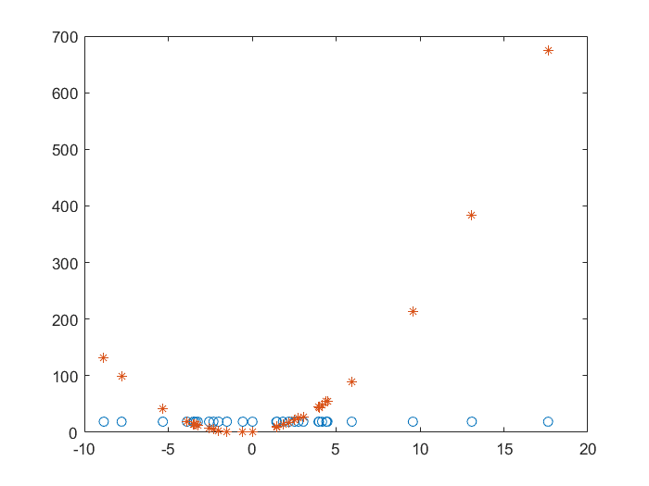

Figure 2. K=0

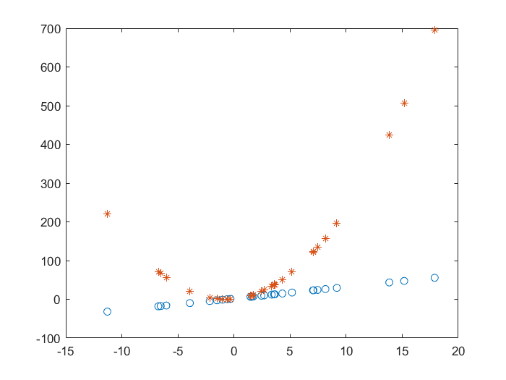

Figure 3. K=1

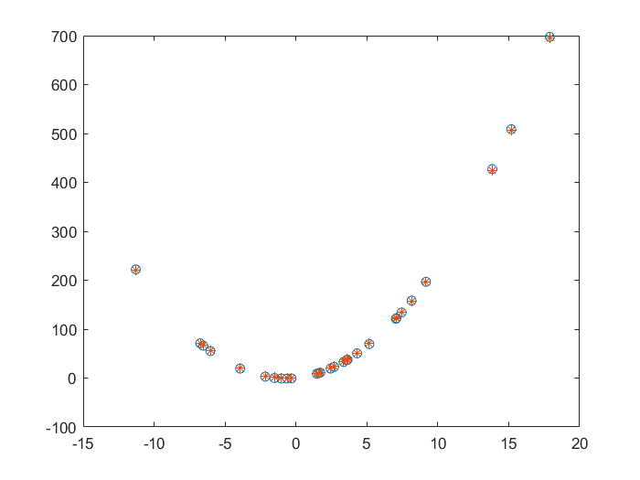

Figure 4. K=2

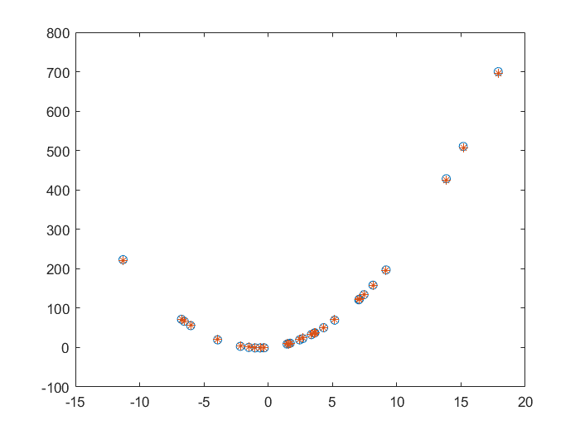

Figure 5. K=3

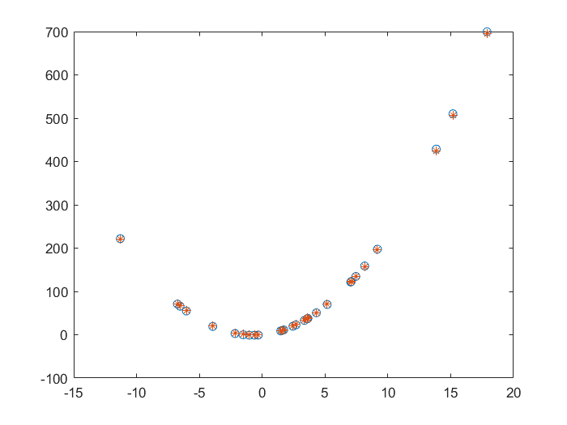

Figure 6. k=2, y=y_exact

2.1. Record your comments and observations in your lab notebook and in the lab report.

Answer: hist(y-y_exact) and hist(y-y_eval) are not like Gaussians and are not similar each other. But the hist(5*randn(300,1)) is like Gaussians. They are shown in figure 7,8,9.

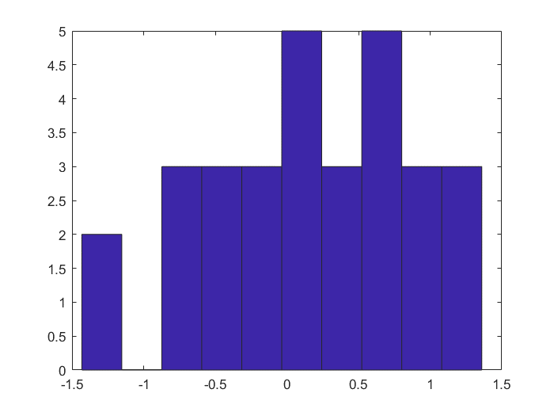

Figure 7. hist(y-y_exact)

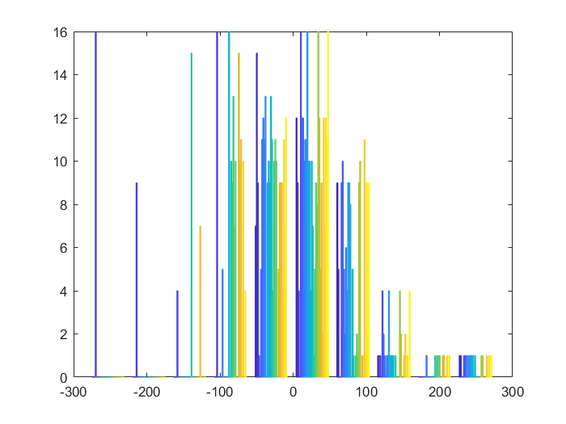

Figure 8. hist(y-y_eval)

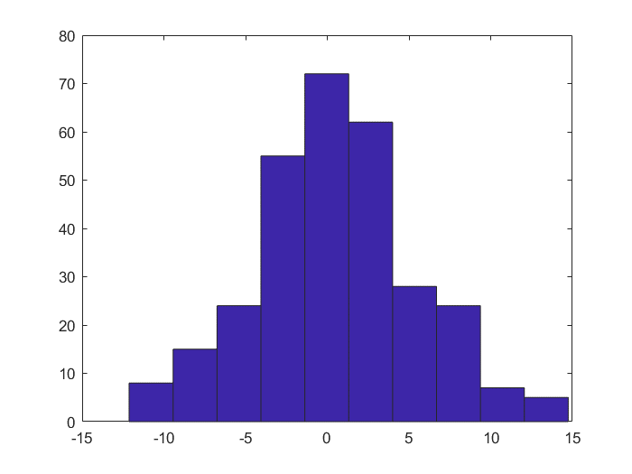

Figure 9. hist(5*randn(300,1))

2.2. Make note in your lab book of your observations, and the probabilities you have calculated and which set of measurements is more likely in each case 1 and 2. Include the plot in your lab report along with the probabilities and your observations.

Answer: because the mean1= 0.2554, standard divination1=1.429 and mean2=5, standard divination2 = 2.828. So when mean offset =1, the P1= 0.755 and P2= 0.089, when mean offset =2, the P1= 0.889 and P2= 0.145. So always the case one is most likely. The picture is shown in figure 10.

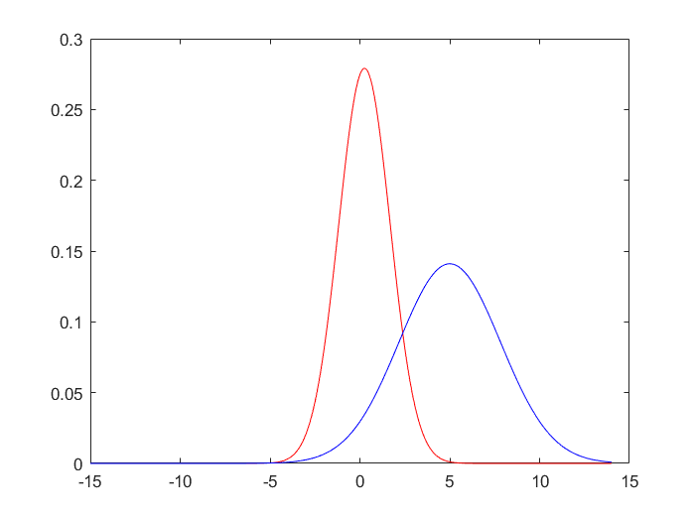

Figure 10. Case 1 and Case 2

3.1. Make note in your lab book of the raw values that the sensor puts out and roughly approximate how they change with the target distance. Include a brief note on these observations in your lab report.

Answer: At 3 cm range, the data is about 550. At 5 cm range, the data is about 832. At 10 cm range, the data is about 848. At 20 cm range, the data is about 500. At 30 cm range, the data is about 415. At 60 cm range, the data is about 161. So in general, the object is more far, the data will be more low. However, when range lower than 10 cm, the data will become lower when range becomes small.

3.2. Include observations of how reliable/consistent (or not) the captured data is in your lab book. Save the plot(s) of your three datasets captured as images and include them in your lab report with a note on the observations made.

Answer: They are reliable in general. Only a few value in dataset 1 and 3 has error. The dataset is shown in figure 11,12,13.

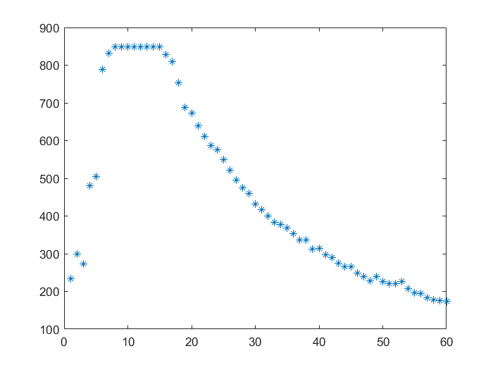

Figure 11. Dataset 1

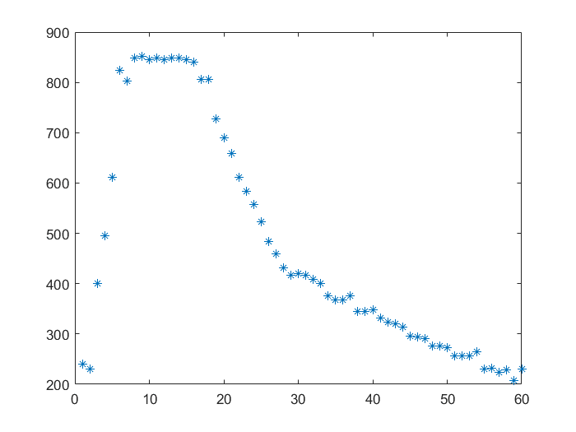

Figure 12. Dataset 2

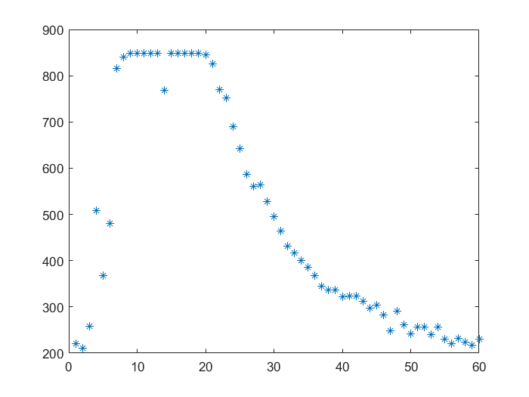

Figure 13. Dataset 3

3.3. Include the parameters calculated and observations of fit quality in your lab notebook and your report. Save the plots generated of the estimated points and include them in your report.

Answer: the figures shows the k=1 and k=2 are under fitting. They are shown in figure 14 and 15.

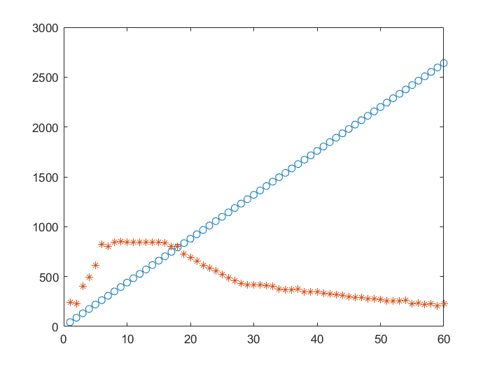

Figure 14. k=1

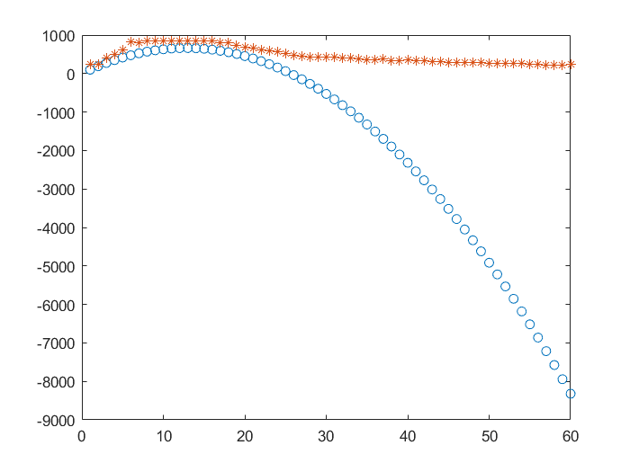

Figure 15. k=2

Lab4.

1. 1) Open the dataset and look at its structure and know how it is constructed. Are you able to create a similar dataset for the binary classification with the SVM?

2) Run the above code, observe and analyse the results you have gotten.

3) Adjust the boundaries (and, therefore, the number of support vectors) by setting a box constraint during training using the 'BoxConstraint' name-value pair argument.

4) Run the code again and compare the results.

5) Make a note and put the above activities into your Lab report 2.

Answer: This dataset can be used in SVM and it has two support vectors when run codes. After change 'BoxConstraint' from 1 to 0.1, it will have 9 support vectors. The results are shown in figure 16 and 17.

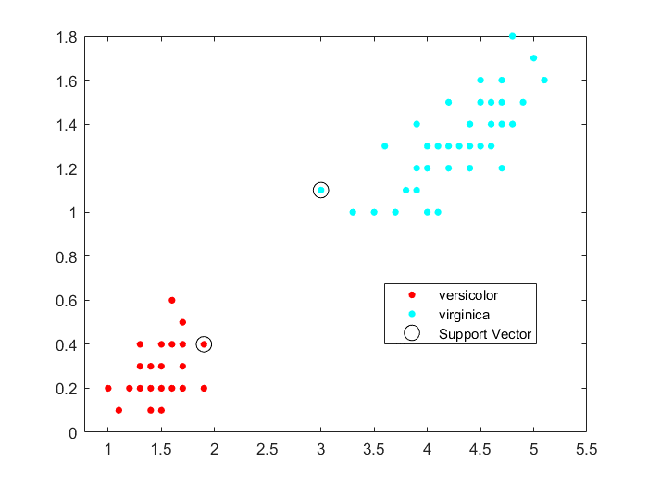

Figure 16. Original Code

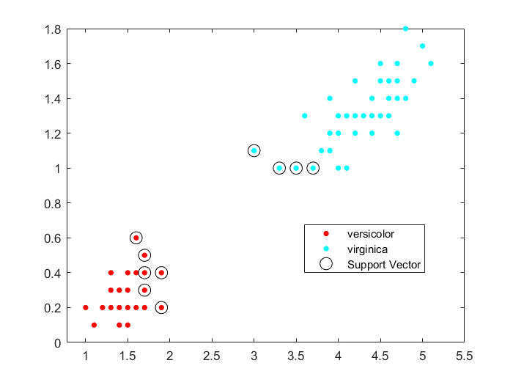

Figure 17. After Changing 'BoxConstraint' to 0.1

2. 1) Create a Matlab script with the code above and give it a name on your own choice.

2) Run the above code, observe and analyse the results you have gotten. Can you get the same results?

3) How do you get less the number of the support vectors? Test your answer and run the code you change again and compare the results

4) Using another kennel function, run the code again, and compare the results with your analysis.

5) Make a note and put the above activities into your Lab report 2

Answer: In this case, it cannot get less support vectors by changing 'BoxConstraint' because the original setting is infinity. This will cause the minimum number of support vectors. But if change the kennel function from ‘rdf’ to ‘polynomial’ the support vector will be less. And it will mean that the ‘rdf’ is better than ‘polynomial’. The results are shown in figure 19 and 20.

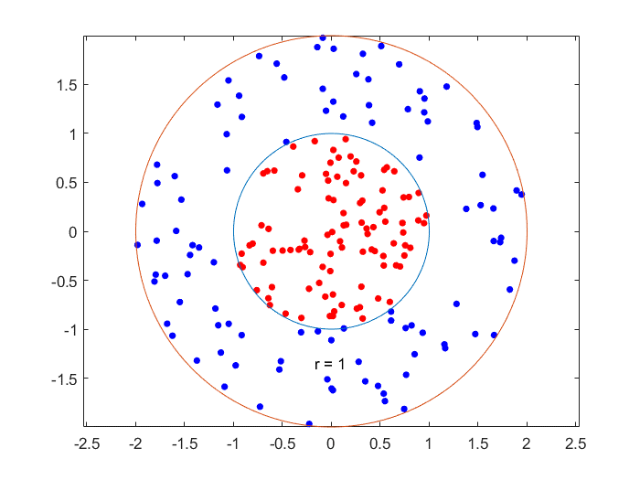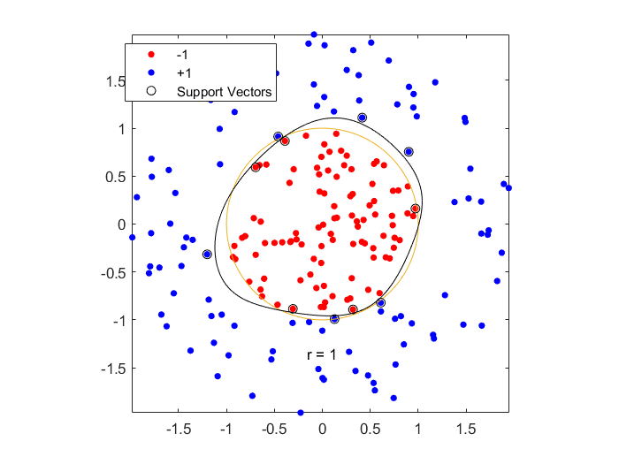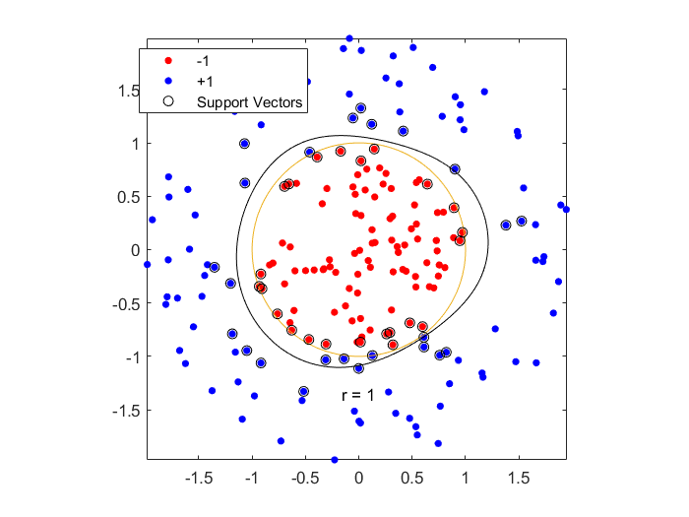

Figure 19. Original Code with ‘rdf’ Function

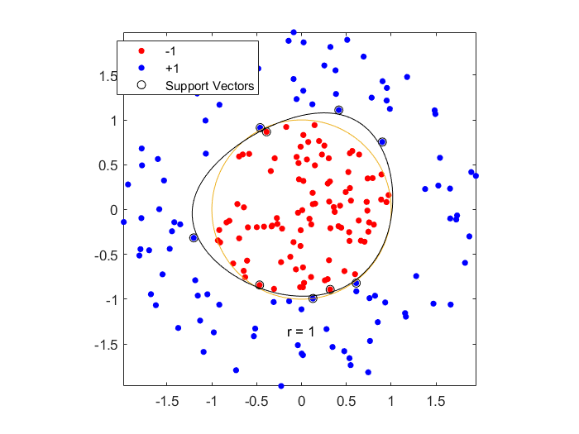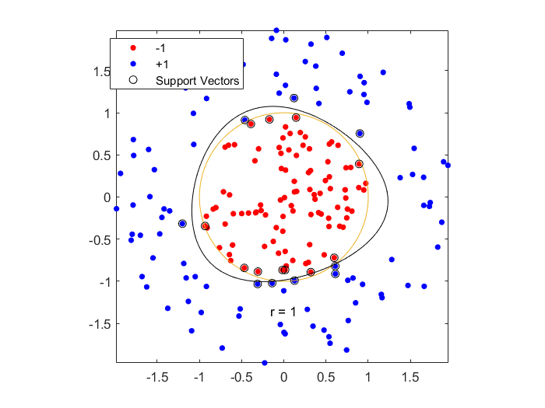

Figure 20. Code with ‘polynomial’ Function

3．I am sorry about this part I cannot finish it. The reason is that the on board sensor of ESP32 are only the touch sensor, hall sensor and inferred controller. The touch sensor need a touch pad to work. The inferred controller cannot use to detect range and it need outside circuit to work. The only choice is hall sensor. However, the train model always be failed because the range data always mix together. So, in my test, this lab may be too hard to design. Many sorry about this.